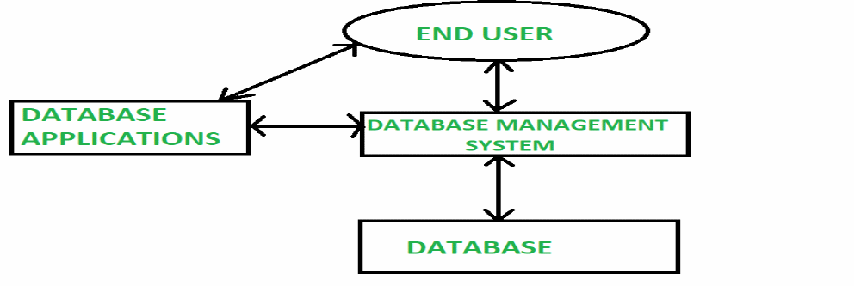
Problems and disadvantage with File System Data Processing

Some advantages of database systems are:

.Reduced data redundancy
- Reduced updating errors and increased consistency
- Greater data integrity and independence from applications programs
- Improved data access to users through use of host and query languages
- Improved data security
- Reduced data entry, storage, and retrieval costs
- Facilitated development of new applications program
they are so many disadvantages so we will see the basic and the most important one in this article I'm going to cover some major disadvantages of file processing system
- Lengthy Development Times

The first and most important problem with the file based system approach is that even the simplest data-retrieval task requires extensive programmer
Disadvantages of the file-based approach
- Inconsistency in data format:
Data inconsistency is a situation where there are multiple tables within a database that deal with the same data but may receive it from different inputs. Inconsistency is generally compounded by data redundancy
- The same information being kept in several different places (files):
- The same information being kept in several different places (files) Data inconsistency, a situation where various copies of the same data are conflicting, wastes storage space and duplicates effort.

2. Difficulty of getting quick answers
The another important problem in traditional file environment system is difficulty of getting quick answers because it needs more queries and more programming for new reports. So, we can’t take the decision very fast.

3.Complex system administration
In the old traditional file based system, system administration becomes more difficult as the number of files increases. Even a simple file system with a few files requires creating and maintaining several file management programs because each file must have its own file management programs that allow the user to add, modify, and delete records.
Also Data theft and loss is an increasingly serious problem. Security has always been a core issues for database administrators, but it's becoming a prominent subject and has a direct effect on many changes that are happening in the IT business today.

4. Lack of security and Limited Data Sharing
Another fault of a file system data repository is a lack of security and limited data sharing. Data sharing and security are closely related. Sharing data among multiple geographically dispersed users introduces a log of security risks .

5. Extensive programming

Making changes to an existing file structure in a file based system environment, it needs extensive programming.
Structural dependence: A data characteristic in which a change in the database schema affects data access, thus requiring changes in all access programs.
Structural independence: A data characteristic in which changes in the database schema do not affect data access

6. Structural dependence

A file based system exhibits structural dependence, which means that access to a file is dependent on its structure.

So the file based system application programs are affected by file structure modification, they exhibit structural dependence. If structural independence exists then it is possible to make changes in the file structure without affecting the application program’s ability to access the data.

